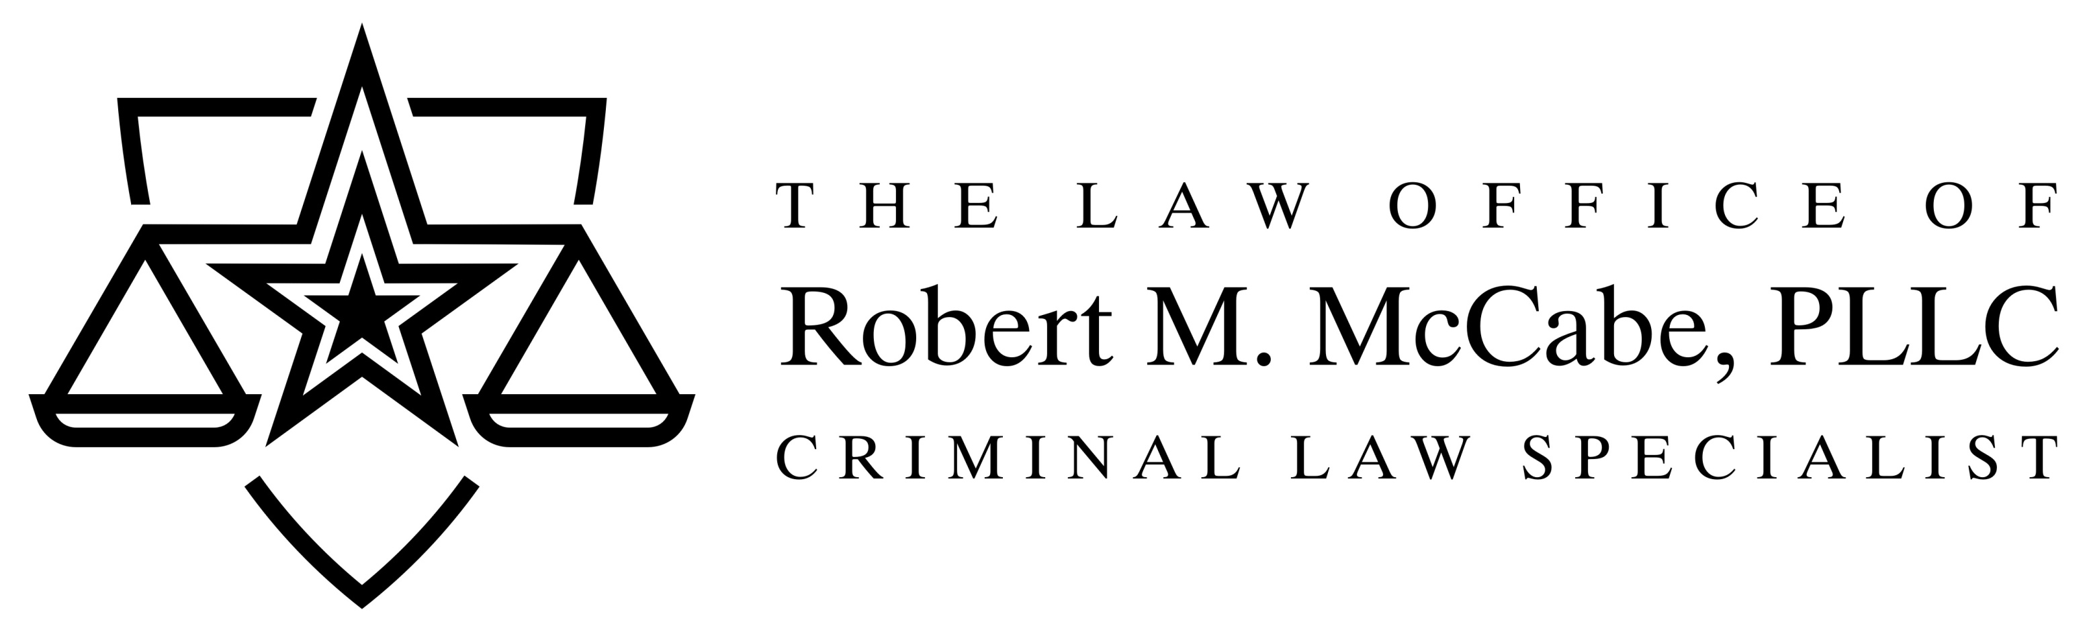
203 South Austin Ave.  Georgetown, Texas 78626  www.defendingtexas.com | (512) 240-5385  (512) 597-3993 Fax | 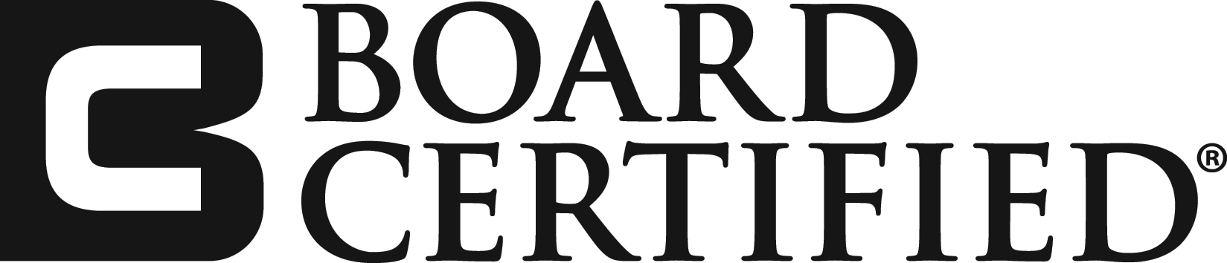  Criminal Law

PRESS RELEASE FOR IMMEDIATE RELEASE

In November 2020, Mike Gleason soundly won the race for Williamson County Sheriff, defeating disgraced incumbent Sheriff Robert Chody by a margin of 33,242 votes.

In December 2020, outgoing Sheriff Chody filed an election contest lawsuit challenging the validity of those election results. Mr. Chody alleged that due to material mistakes, illegalities, and/or fraud which occurred in the administrating and tabulation of the election results, that the true outcome of the election could not be ascertained.
On May 4, 2021, after several months of Mr. Chody taking no material action to advance these claims, Sheriff Gleason, through his attorney, Robert M. McCabe, filed a “plea to the jurisdiction,” challenging the court’s legal ability to hear the suit, based on the wild and uncorroborated assertions made by Mr. Chody.
On July 12, 2021, at 9:00 A.M., this matter was set to be heard by the Hon. James E. Morgan, sitting by special assignment in the 395th District Court. Just prior to the hearing, Mr. Chody, through his attorney, Kellye SoRelle, announced that he planned to file a “non-suit.” A non-suit serves as notice that Mr. Chody has voluntarily stopped the election contest on the grounds of his failure to make a legal case or bring sufficient evidence. On July 14, 2021, Mr. Chody filed the non-suit with prejudice, barring him from raising another frivolous election claim related to the election.
Sheriff Gleason’s attorney, Robert M. McCabe, stated, “although we fully support access to the court system to determine rightful election results where allegations of actual fraud or illegal voting materially affected the outcome of a contested race, that right was bastardized by Mr. Chody in his attempt to usurp the true will of the voters in their overwhelming choice of electing Mike Gleason to the office of Sheriff of Williamson County.”
Sheriff Mike Gleason stated, “Robert Chody continues to leave a path of death, destruction and shame upon the badge he once wore. This baseless suit has not deterred my office from continuing to investigate him and his previous administration as allegations of their misconduct and criminal conduct trickle in.”

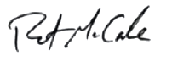
Robert M. McCabe
Attorney for Williamson County Sheriff Mike Gleason
Robert@defendingtexas.com

